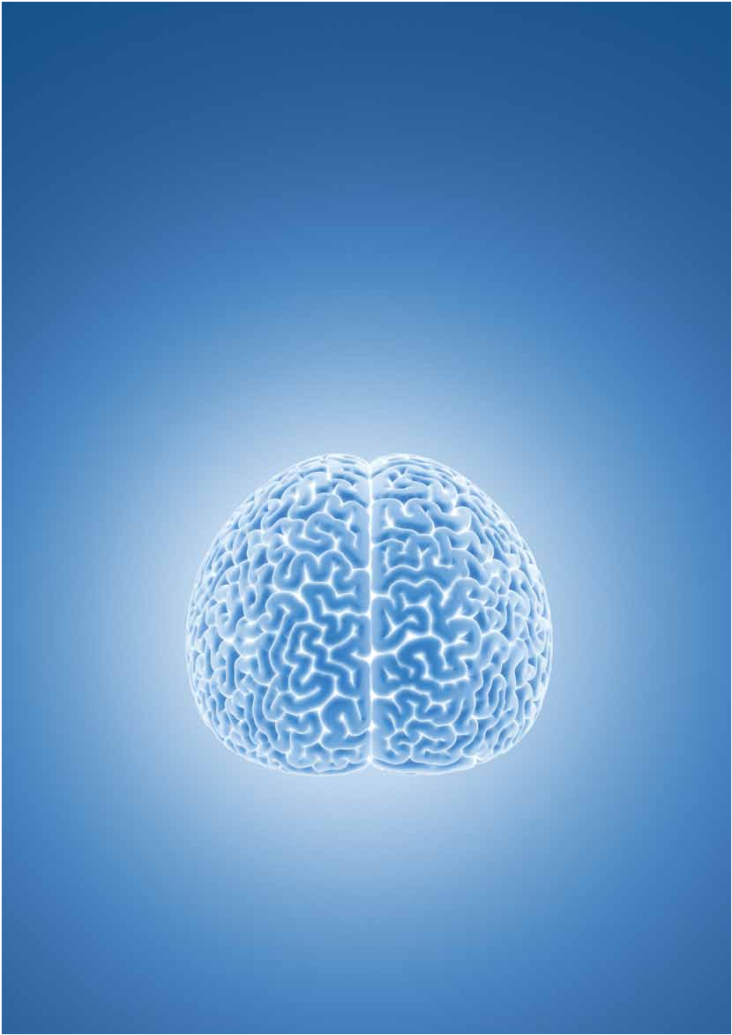
THE LATEST NEWS & VIEWS FROM PHYSIOTHERAPY NEW ZEALAND JUNE 2017
PHYSIO

MATTERS

Neuroplasticity: Training the brain for skill development

ISSN 1179-7967 (Print) www.pnz.org.nz ISSN 1179-7975 (Online)

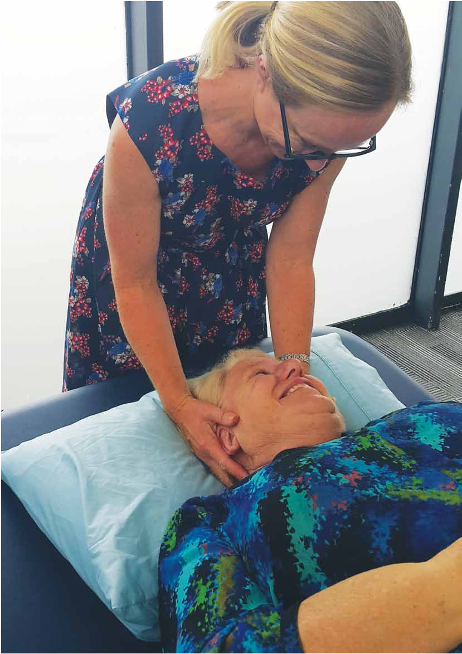
FEATuRE

Neuroplasticity:
Training the brain for skill development

Neuroplasticity is the brain’s ability to reorganise itself by forming new neural connections throughout life. It allows the neurons in the brain to compensate for injury and disease and to adjust their activities in response to learning, experience or following injury. Esther Bullen discovers how physiotherapists can help clients re-educate their brains for rehabilitation.

Our brains are constantly changing – all day, every day, including in our sleep. This is neuroplasticity at work, and it begins from the moment we first develop nerve cells and continues until we die.

Simply put, says clinical neuroscientist Associate Professor Cathy Stinear from the university of Auckland, neuroplasticity is the process that changes the number and strength of connections (or synapses) between neurons – you strengthen the connections you use and weaken the ones you don’t. When we develop
a new skill, the parts of the brain responsible for that skill become better connected to one another. When we stop utilising that skill, the connections weaken, and we become rusty.
“It’s a misconception that neuroplasticity only strengthens connections, because it weakens them too,” says Cathy. “And that makes sense when you think about it, because otherwise you would remember every single thing that you’ve ever experienced, and that would be cumbersome. This should help physiotherapists understand why their patients get worse if they stop practicing. Disuse or non-use leads to
the weakening of those connections.”

So, what is the physiotherapist’s role in this learning process? “Their patient’s brain has to change in order for them to learn anything. So, the question for the therapist isn’t ‘how do I change the patient’s brain?’ Trust me, it’s changing with or without you. It’s more, ‘how
do I help this person learn this thing as efficiently and as effectively as possible?’”
Optimum learning conditions

Studies have shown that there are three conditions for optimum learning: challenge, attention and motivation.
If all these conditions of learning are met, learning increases. “When we are challenged, paying attention, motivated and feeling rewarded, we release
neurotransmitters that help the brain

to strengthen synapses, so that boosts learning,” says Cathy.
Challenge

For physiotherapists, challenging patients means making exercises progressively difficult. In therapy, this is the concept of progression: “Once someone is getting quite good at a task, you have to make it a little bit harder again to keep extending what they are able to do,” says Cathy.
Attention

Research shows that if someone is performing a task but their mind is elsewhere, the task will not change their brain in the same way as when they are paying attention. “So, as
a patient is performing a task or practicing it, you don’t want to be spending too much time talking about extraneous things,” says Cathy. “You do need to help them pay attention to what it is they are doing.”
Motivation and reward

A third and important element for learning is motivation: your patient must want to be there and must be fully engaged. Otherwise, says Cathy, they won’t learn as much and they won’t make as many gains from
that experience. Part of motivation is reward; if people feel rewarded for the thing that they are practising, that helps their learning. In a rehabilitation setting, the reward might be regaining the ability to do something important or meaningful, like playing with their grandchild or cooking for their family.
Timing

The time it takes for an individual to master a skill is too complex to call, says Cathy, because it relies on a number of factors. “All the literature
tells us that you need many repetitions

Cathy Stinear

of something to become really good at it. But the exact number varies hugely from person to person, and depending on how complex the skill is.” Other determining factors include an individual’s genetic makeup; their motivation, attention and engagement with the task, their age, and the skills they bring to it.
The effects of aging will impact on learning, says Cathy. Research has shown that those aged 80 years and above take longer to master new skills than the same skill by a person aged 40 years, but the difference is not huge. And, as is usually the case, there will always be exceptions. In terms of skill development between children and adults, Cathy says adults have the advantage of more complex cognitive processing and motor skills as well as experience to draw on.
Research

Research in neuroscience is constantly changing the way physiotherapists work. Cathy and her team at the university of Auckland are leading cutting-edge research that uses research tools in a clinical setting, and in doing so, maximises the learning and rehabilitation of stroke patients.

PHYSIO MATTERS JUNE 2017 | 7

FEATuRE

The most recent findings, published in the international medical journal Stroke, demonstrate how the team’s unique PREP algorithm (Predicting REcovery Potential) can be used by therapists to accurately predict upper limb outcomes for individual patients. For therapists, it takes the guessing
game out of upper limb rehabilitation.

“For a long time, therapists have relied on their clinical assessment of the patient. But that doesn’t tell
them much about the patient’s brain, which is where the stroke happened and where all the recovery is going to happen. That’s what this algorithm does – it gives therapy teams useful information about the patient’s brain
that then predicts how well that patient is likely to recover, and lets us tailor their rehabilitation accordingly.”
The study found that these patients could leave hospital a week earlier than normally expected. Once therapists and patients have this information, the therapists are more confident, and they
can tailor the rehabilitation appropriately for the patient, which helps them leave hospital a week earlier. And that is a really good thing because we know, particularly for our older patients, the more time they spend in hospital, the more they decondition.
Foster hope

Gilly Davy

For successful learning to take place, neuro physiotherapist Gilly Davy of
Connect Neuro Physiotherapy says first
and foremost clients need hope. “The client has to be able to believe that change is possible, and my main aim in the first couple of sessions is to be
able to empower the individual to have hopes, goals and aspirations.”
Part of this process involves relationship building. “The client needs to trust the therapist and have the confidence that the therapist is going to do their absolute best for them individually,” says Gilly. She gets to know her clients: what drives them, what inspires them, their likes and dislikes, and what makes them different from everyone else.
Based on the latest research, Gilly has compiled six key principals for driving neuroplasticity and rehabilitation which she applies in her programmes. In order of importance, these are:
1. Meaningful activities

Gilly ensures that hands-on therapy is carried over into functional exercises and into day-to-day living. All her programs have an emphasis on self-management.

2. High intensity

Clients need to work hard enough so that they are getting out of breath three to four times per week, says Gilly. “When you work at 70% to 80% of your predicted maximum heart rate, you release brain-derived neurotrophic factors (BDNF), which are nerve growth hormones which increase synaptic activity in the central nervous system.

3. Repetition

To form an autonomic pathway or to master a new skill requires hours and hours of practise, says Gilly. She says research suggests approximately 300 repetitions an hour for upper limb training and 2,000 steps an hour for lower limb.

4. Challenge

Make tasks challenging, says
Gilly. “Complex tasks that involve

dual- and multi-tasking create more brain activity, and that drives
neuromodulation with increased nerve cell growth when compared to non-challenging tasks.”

5. Specificity

Be specific about your treatment, says Gilly: “Everyone is individual and you need to address their specific impairment. For example, which muscles are weak, not aligned or in balance deficits?”

6. Variation and timing:

The more variation in a task the better it promotes function, says Gilly.
Make it meaningful

Julie Rope

Neuro physiotherapist Julie Rope of Rope Neuro Physiotherapy says patients learn best if tasks are meaningful – that is, functional – and, ideally, practised in the environment in which they are to be performed.
Keep it fun: by being creative and knowing what motivates her patients, Julie can incorporate an element of fun into most treatments.
Julie uses repetitive tasks with adequate intensity. She says finding the right balance of intensity is important: there needs to be enough intensity that learning takes place but not so much that physical and cognitive fatigue inhibits learning.
If patients are fatigued, it is hard to

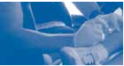
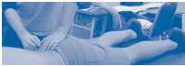
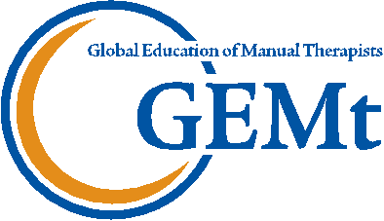
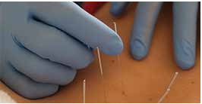
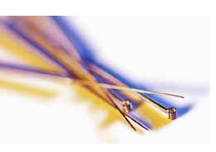
APPLY!
BIRD RATES
EARLY
Face to Face Learning
World Class Education

These courses will change the Professional Instructors way you view the human body! Ongoing Clinical Support
Money Back Guarantee
TRIGGER POINT DRY NEEDLING COURSES 2017 Applications for Pain Management & Sports Injuries
Treatment techniques combining the IMS and Trigger Point Models maximising clinical outcomes.

2017 COURSE LOCATIONS:

AUCKLAND, CHRISTCHURCH, MELBOURNE, CAA Accredited Courses SYDNEY, KUALA LUMPUR & MORE! Osteopathy Australia Endorsed Courses
For more information, visit our website, call +61 3 9585 8100 or email courses@gemtinfo.com.au
REGISTER ONLINE | @ w | ww.gemtinfo.com.au

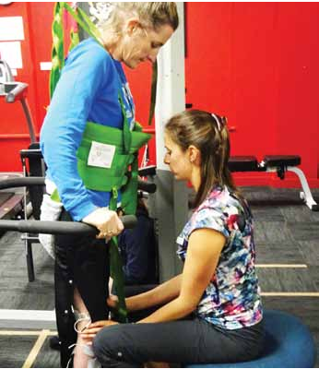
learn, so Julie equips her patients with advice on rest and sleep. If fatigue is an issue for the client, she will offer home-based therapy sessions at a time when they are most alert.
To learn best, patients need to know what to expect from their treatment, says Julie. She will spend time setting the scene for the treatment and will give clients the opportunity to ask questions. Because everyone learns differently, she begins with a variety of different teaching techniques,
such as verbal diagrammatic instruction and non-verbal demonstration or mirroring, to find out what works best for that patient.
In Julie’s experience, patients who learn quickly tend to have good support networks, a positive engagement with the programme and are accepting of their new condition. “It is important to recognise where patients are on their journey through grieving and acceptance of what has happened to them and the effect on their life as it was and the role they had,” says Julie.
Written by Esther Bullen

PHYSIO MATTERS JUNE 2017

